
Valley Primary School
Class names
YEAR 6
OLYMPIANS: P.E. CURRICULUM ENRICHMENT.
Ennis 6 | Jessica Ennis | 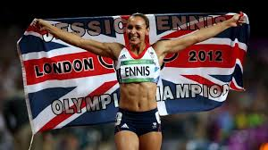 | Dame Jessica Ennis-Hill 1986 –  A British track and field athlete specialising in multi-event disciplines. A three-time world champion, 2009, 2011 and 2015 and European champion in 2010.  Born in Sheffield.
Farah 6 | Mo Farrah | 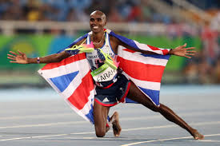 | Sir Mohamed Farrah 1983 –  A British distance runner. He is the most successful British track athlete in modern Olympic Games history. He is the 2012 and 2016 Olympic gold medallist in both the 5,000m and the 10,000m events.  Born in Somalia, he escaped civil war by fleeing to London and later became a British citizen.
Simmonds 6 | Ellie Simmonds | 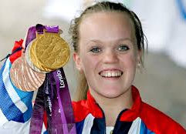 | Eleanor Simmonds 1994 –  A British Paralympian swimmer who won gold medals in the 2008 Summer Paralympics in Beijing, the 2012 Paralympics in London and the Rio Paralympics in 2016. Ellie Simmonds has achondroplasia dwarfism and is only 4 feet tall (1.23m)  Born in Walsall.
YEAR 5
MUSICIANS: MUSIC CURRICULUM ENRICHMENT.
Holst 5 | Gustav Holst | 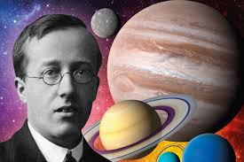 | Gustav Holst 1874-1934  A British composer, arranger and teacher best known for his orchestral suite “The Planets.”  His compositions were influenced by Wagner and Strauss.  Born in Cheltenham.
Lynn 5 | Vera Lynn | 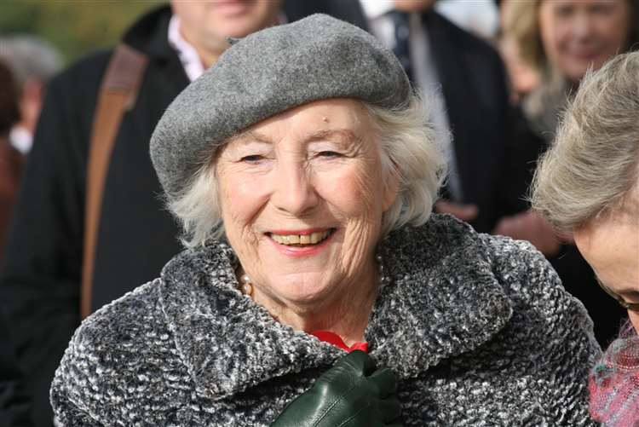 | Dame Vera Lynn 1917 –  British singer and actress whose performances were enormously popular during World War 2. Known as “The Forces Sweetheart” she is famous for, “We’ll meet again” and “The White Cliffs of Dover.”  Born in London.
Webber 5 | Andrew Lloyd-Webber | 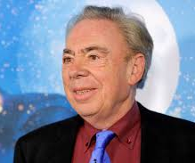 | The Right Honourable Lord Andrew Lloyd-Webber 1948 –  A British composer and impresario of musical theatre. Particularly famous for composing thirteen musicals and two film scores.  In 1992 he was “knighted” and given a peerage by Queen Elizabeth 11 for his services to the Arts.  Born in London.
YEAR 4
SCIENTISTS: SCIENCE CURRICULUM ENRICHMENT.
Hawking 4 | Stephen Hawking | 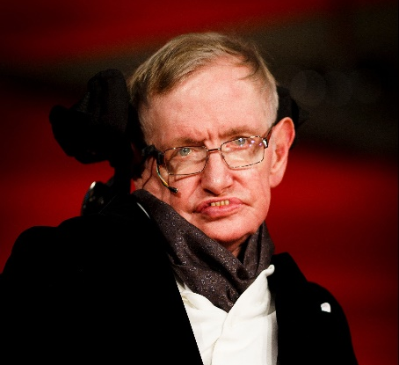 | Stephen Hawking 1942-2018  A British physicist and cosmologist and professor of mathematics.  Hawkins suffered from the slow-progressing motor neurone disease that gradually, over the decades paralysed him. Although he lost his speech, he was able to communicate through a speech-generating device.  Born in Oxfordshire
Newton 4 | Isaac Newton | 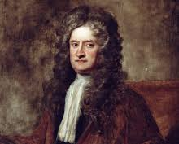 | Isaac Newton 1642-1726  A British mathematician, physicist and astronomer who is widely recognised as one of the most influential scientists of all time. Famous for seeing an apple fall which inspired him to think about the force of gravity.  Born in Lincolnshire.
Sharman 4 | Helen Sharman | 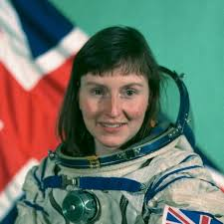 | Helen Sharman 1963 –  The first British, woman astronaut and space explorer.  She was the first British astronaut who spent 8 days in space working as a crew member of the Russian Mir station and taking part in Project Juno.  Born in Sheffield.
YEAR 3
ARTISTS: ART AND DESIGN CURRICULUM ENRICHMENT.
Hockney 3 | David Hockney | 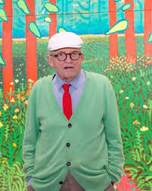 | David Hockney 1937 –  British painter, designer and photographer. Well known in the Pop Art movement of the 1960’s.  In 2018, “Portrait of an artist,” (pool with two figures) sold for £70 million.  He is considered one of the most influential of the British artists of the 20th Century.  Born in Bradford.
Lowry 3 | L. S. Lowry | 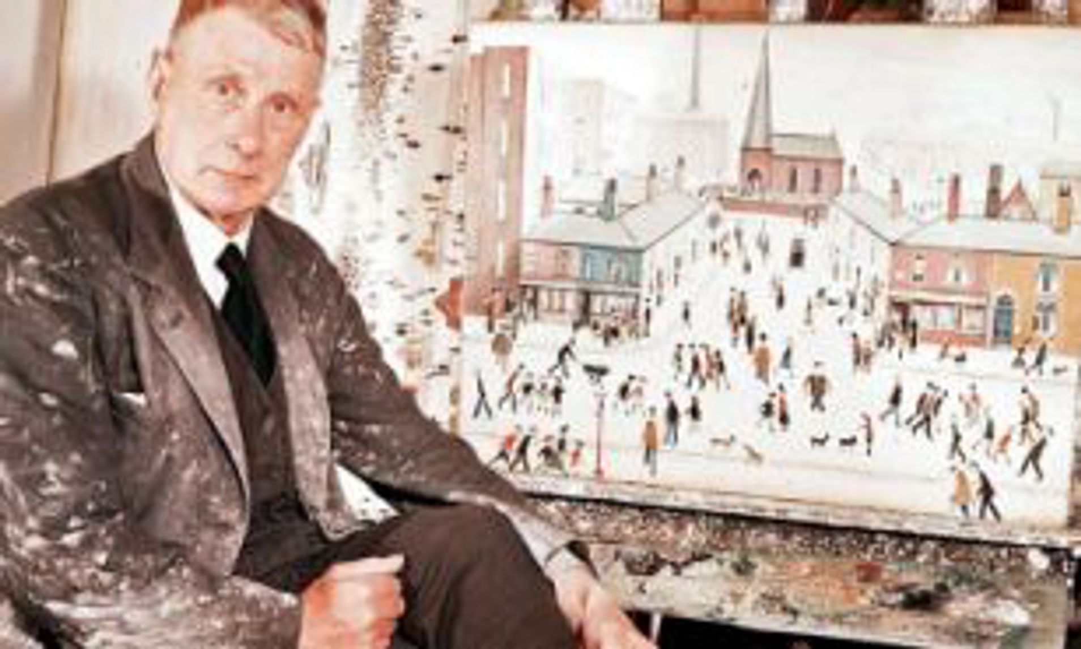 | Laurence Stephen Lowry 1887-1976  Famous for painting scenes of life in the industrial districts of North West England. He developed a distinctive style of painting and is best known for his human figures which are referred to as “matchstick men.”  Born in Lancashire.
Riley 3 | Bridget Riley. | 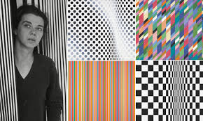 | Bridget Riley 1931-  Known especially for her Optical Art paintings, mainly in black and white.  She was a figurative and semi-impressionist artist who also embraced the pointillist technique inspired by Georges Seurat.  Born in London.
YEAR 2
HISTORIANS: HISTORY CURRICULUM ENRICHMENT.
Churchill 2 | Winston Churchill | 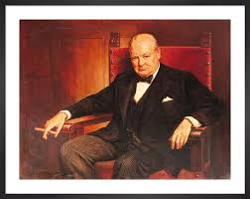 | Sir Winston Leonard Spencer-Churchill 1874-1965  Prime Minister of the UK 1940-1945 who led Britain to victory in WW2.  Re-elected as Prime Minister 1951-1955.  He was known for his inspiring speeches and refusal to give in even when things were going badly.  Born in Blenheim, Oxfordshire.
Nightingale 2 | Florence Nightingale | 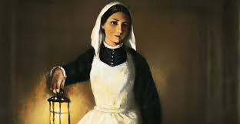 | Florence Nightingale 1820-1910  The founder of modern nursing who was prominent during the Crimean War (1853-1856) where she organised care for wounded soldiers.  She was known as “The lady with the lamp,” because she would often check on soldiers throughout the night.  Born in Florence but has British nationality.
Pankhurst 2 | Emmeline Pankhurst | 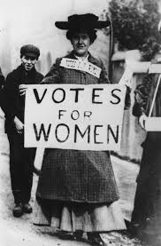 | Emmeline Pankhurst 1858-1928  British political activist who organised the suffragette movement and helped women win the right to vote.  Emmeline died in 1928 and shortly after women were granted equal voting rights with men (once they reached 21 years old)  Born in Manchester.
YEAR 1
TECHNOLOGISTS: COMPUTING CURRICULUM ENRICHMENT.
Bell 1 | Alexander Graham Bell | 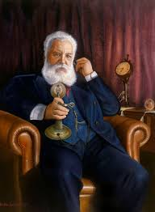 | Alexander Graham Bell 1847-1922  Invented the first practical telephone.  He sent voice signals down a telegraph wire.  Born in Scotland.
Lee 1 | Tim Berners-Lee | 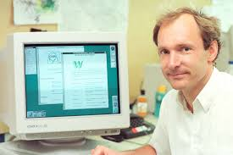 | Sir Tim Berners-Lee 1955-  Engineer and computer scientist who invented the World Wide Web.  In 1989 he implemented the first, successful communication between a Hypertext Transfer Protocol (HTTP) client and the server via the internet.  Born in London.
Shaw 1 | Percy Shaw | 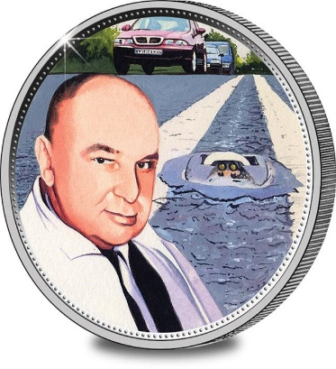 | Percy Shaw 1890-1976  He invented the reflective studs, known as cat’s eyes, for lighting the way along roads in the dark. The robust reflective lens are caught in a car’s headlamps and have probably saved thousands of lives.  Born in Halifax.
RECEPTION
EXPLORERS: GEOGRAPHY CURRICULUM ENRICHMENT.
Aston R | Felicity Aston |  | Felicity Aston 1977-  The first woman to ski alone across Antarctica. She has organised and led numerous expeditions for women to remote areas around the world but particularly to the Polar regions.  Born in Sevenoaks, Kent.
Grylls R | Bear Grylls | 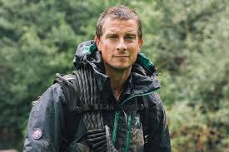 | Edward Michael Grylls 1974 –  Former SAS serviceman. survival instructor, adventurer, writer and television presenter.  He has been involved in numerous survival activities.  Born in London.
Peake R | Tim Peake | 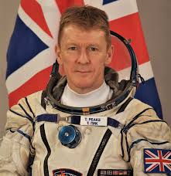 | Tim Peake 1972-  British astronaut who became the first, official British astronaut to walk in space.  He spent 6 months at the International Space Station and, during his mission, took part in 250 scientific experiments.  Born in Chichester.
NURSERY
INVENTORS: DESIGN TECHNOLOGY CURRICULUM ENRICHMENT.
Starley N | James Starley | 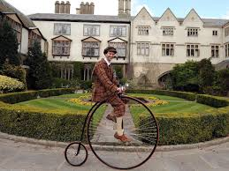 | James Starley 1830-1881  British inventor and father of the bicycle industry. In 1871 he invented The Penny Farthing bicycle which had a small rear wheel with a large front wheel, a simple tubular frame and rubber tyres.  It really was the first efficient bicycle.  Born in Coventry.
Whittle N | Frank Whittle | 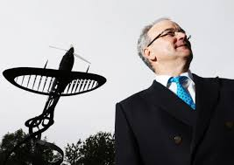 | Frank Whittle 1907-1996  British aviation engineer and pilot who invented the turbo-jet engine.  He realised that for planes to fly longer distances they needed to fly at higher altitude where the air resistance was lower, and speed could be greater. This led him to invent a jet engine. One of Frank Whittles first planes was the Gloster Meteor Jet.  Born in Coventry.
Royce N | Henry Royce | 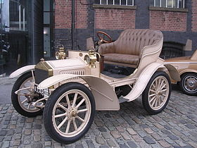 | Henry Royce 1863-1933  British engineer famous for his design of cars and engines.  Royce developed a great fascination with all things engineering and mechanical and developed his own car.  Rolls-Royce was formed through a partnership with a man called Rolls and created horsepower motor cars famous for reliability and longevity.

