Valley Primary School

GROWING AND LEARNING TOGETHER TO BE THE BEST WE CAN BE !

ASPIRE…ENJOY…ACHIEVE…CHALLENGE !

Head Teacher: Miss S. Milewski

Junior Site: Old Lode Lane, Solihull, B92 8LW. Tel: 0121 743 4691 officejuniors@valley.solihull.sch.uk
Infant Site: Fallowfield Road, Solihull, B92 9HQ. Tel: 0121 743 4691 officeinfants@valley.solihull.sch.uk

Tuesday 11th March 2025

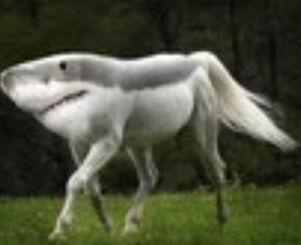
A shark that can walk An elephant that can fly

Dear Parents/Carers,
We have been celebrating National Science Week today and the children have thoroughly enjoyed spending the day taking part in lots of Science activities.
As the theme this year is ‘Change and Adapt’ we have decided to run a competition linked to this theme. Wouldn’t it be exciting if we could create a new animal in our world? Now we have the chance in this year’s competition.

We would like your child to create a new animal, thinking carefully about adaptions they will need to survive in their environment. Think about teeth, body, how they move, what they eat, where they live and how they protect themselves from predators. Your child could choose to add features from different animals to create their new animal.

The deadline for this competition is Tuesday 1st April 2025 and winners will be announced in assembly the following week. Entries must be brought into school and given to your child’s class teacher.
We are really looking forward to seeing how many new creatures we can create at Valley..

Thank you for your support,
STEM Team


