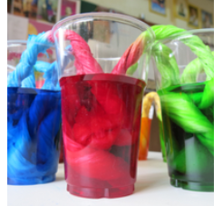
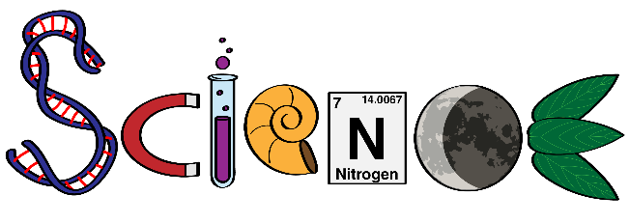
Friday Science Home Experiment
Walking Rainbow Colour Science Experiment


 Adult supervision

- several colours of food colouring
- 3 clear plastic cups or glasses of the same size
- paper towels
- water


- Select the colours you would like to incorporate into the Walking Rainbow Water experiment.
- Add a few drops of food colouring to a cup. Then fill the rest of the cup about halfway full. (with room temperature water)
- Now replicate this step but use a new unique colour. You need to have an extra empty glass of the exact same size for the water to walk into.
- Cut a paper towel in half and after that fold it into quarters lengthwise.
- Put one end of the paper towel into the coloured water and another end into the empty jar. Now use the other halved and folded piece of paper towel by placing one end in the other cup of coloured water and its opposite end into the empty cup.
- Wait for the science to take place! You should soon see both coloured waters climbing the paper towels and joining in the empty cup.


Because of capillary action, the water flows, or “walks” up and over the paper towels right into the empty cup. The empty cup fills up with water until the water levels of every one of the cups are equal. The original colours will mix creating a new colour.
Try different colours. Try expanding the experiment with more cups or jars of coloured water and additional empty vessels to see how far you can make the water walk. Try different types of paper. Try substituting water with vinegar. Try adding salt to the water. Try very cold water.
Share your experiment with your teacher using the class email or bring in to show your classmates.

