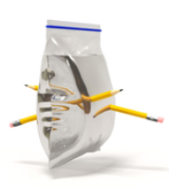
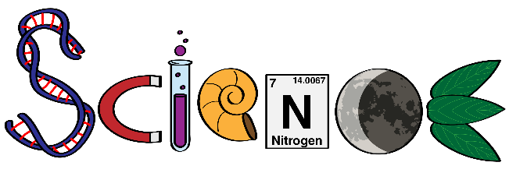
Thursday Science Home Experiment


 Adult supervision
Complete the activity over the sink.

- plastic food bag with a zip
- water
- pencil sharpener
- several pencils
- optional – food colouring and/or glitter


- Use the pencil sharpener and carefully make each pencil as sharp as possible.
- Fill the bag to about three quarters of the way full with water.
- Optional – Add a little food colouring and glitter for fun.
- Push any air out of the bag.
- Seal the bag securely.
- Hold the bag firmly out in front of yourself.
- Use your other hand to push a pencil through the bag so it pokes out the other side.
- Continue stabbing the pencils through the bag, being sure to leave the pencils in the bag.


Plastic zip close storage bags are very flexible. The bags are made from a polymer called low density polyethylene. The sharpened pencils can squeeze through the chains of polymer without breaking them and the bag is so flexible it is able to seal around the pencils preventing water from escaping.
Try using a balloon.
Try using a plastic grocery bag.
Try adding warm water to the bag.
Share your experiment with your teacher using the class email or bring in to show your classmates.

