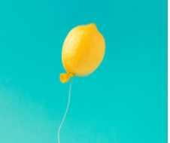
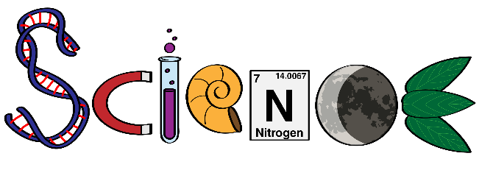
Wednesday Science Home Experiment
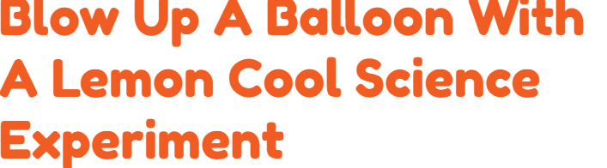

- lemon
- knife
- glass
- empty water bottle
- balloon
- water
- baking soda
 Adult supervision when using knives.

- Add 2 tablespoons (30ml) of water into a bottle.
- Now add a teaspoon of baking soda to the bottle. Swirl the bottle around to mix the water and baking soda thoroughly.
- Stretch out the balloon and have it ready to put over the mouth of the bottle.
- Cut the lemon in half and squeeze the juice into a glass.
- Pour the lemon juice into the bottle and quickly secure it over the mouth of the bottle.
- The balloon should inflate.

This experiment uses a chemical reaction to inflate a balloon. These types of chemical reactions cool their immediate area and the bottle should feel cool to the touch. The lemon contains citric acid that when combined with baking soda causes a chemical reaction. This chemical reaction releases carbon dioxide gas. The carbon dioxide will not be able to escape the bottle due to the balloon being stretched over the mouth of the bottle. The pressure will build and cause the balloon to inflate.
Try different sized bottles.
Try different sized balloons. Try vinegar.
Share your experiment with your teacher using the class email or bring in to show your classmates.

