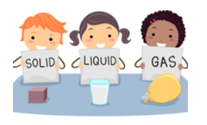
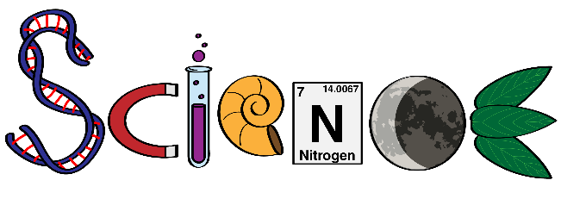
Tuesday Science Home Experiment
Bag Full Of States Of Matter Easy Science Experiment

- ice cube tray
- water
- food colouring
- ziplock bag
- masking tape


- Fill the ice cube tray with water. Add a drop of food colouring in each section for fun. You can even add several different colours if you like.
- Put the tray into the freezer until it freezes solid.
- Remove the tray from the freezer once the cubes have hardened and put four to six cubes inside your Ziplock bag.
- Zip the bag closed securely and tape it to a window, which will receive lots of sunlight.
- Check back frequently and observe any changes to the ice cubes.
- As you probably expected, the ice cubes eventually melted.
- Now, open the bag and reattach it to the window with tape in a way that makes sure the contents does not spill out and that the bag remains open.
- Check back daily and eventually the liquid will be gone.


When the water freezes it becomes a solid. Once the ice melts, the water returns to its liquid form. Over time, the water will turn into a gas as it evaporates. This entire process is known as the water cycle and it also allows you to observe the three states of matter: solid, liquid, and gas.

Try zipping the bag closed and observe what happens.
Try adding salt to the water before freezing.

Share your experiment with your teacher using the class email or bring in to show your classmates.

