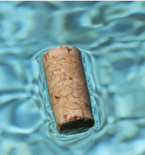
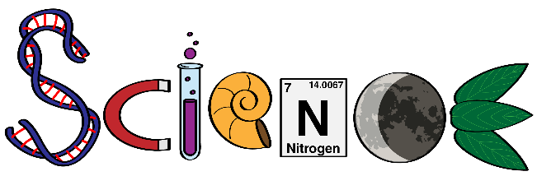
Monday Science Home Experiment


- cork
- glass
- water
- teaspoon



- Fill the glass nearly full with water.
- Place the cork in the centre of the glass (without touching the edge)
- Blow on the cork to try and keep it centred.
- Eventually the cork will hit the side of the glass.
- Now add water (a teaspoon at a time) and observe what happens.



As you add small amounts of water to the glass, the surface tension will rise above the rim of the glass. This will create a slightly rounded surface with the highest point being centred. The cork will float to the highest point and will stay centred allowing you to complete the cork challenge.

Try different items that float.
Try adding dish soap to see if it changes the surface tension.
Try different shaped glasses.

Share your experiment with your teacher using the class email or bring in to show your classmates.

