Please complete your experiment with an adult
Monday Home Experiment
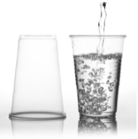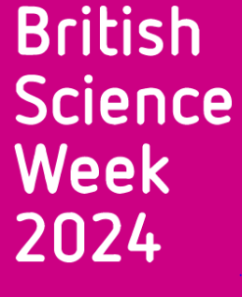

- A small plastic cup.
- Sink or outside area that can get wet.
- Playing card or piece of card
- Optional – Little foam balls or something that will float. This adds to the magical illusion of the experiment.


- Fill the cup about three quarters of the way full with water.
- Optional – Add your floating items.
- Place the playing card over the top of the cup making sure the card covers the entire top of the cup.
- Press gently against the card as you rotate the cup upside down. Be sure to do so over a sink in case of any accidental spills.
- After a few moments, remove your hand. The water will appear to magically stay in the cup!


When you place the card on the cup of water, the air pressure inside and outside the cup is the same. As you turn the cup over, a tiny amount of water will escape. This seemingly insignificant amount of water causes the volume of air in the cup to increase. While the volume of air in the cup stays the same, this causes the air pressure inside the cup to decrease. The card will now stay in place even though the cup is upside down because the air pressure outside the cup in now higher than the air pressure inside the cup.

Use larger cups with larger amounts of water.

Send us a video or a photograph using the Teams assignment.

Please complete your experiment with an adult
Tuesday Home Experiment
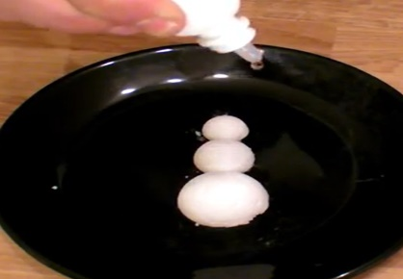

https://www.youtube.com/watch?v=L0wEwHmYEiQ&feature=youtu.be
- 1/3 cup baking soda per snowball
- 1 1/2 tablespoons vinegar per snowball
- Pipette/dropper
- Add baking soda to water until baking soda becomes packable dough, not runny or watery.
- Shape into a ball.
- Put it in the freezer.
- Put a few drops of vinegar onto your snowballs. Move back and watch them sizzle as if it is spring!
Acids and Bases will erupt if mixed together.
Acid (Vinegar) + Base (Baking Soda)= Carbon Dioxide

Try adding blue food colouring to the vinegar. Does this change the experiment?
Try warming up the vinegar before you squirt it onto the snowballs. Is the reaction different? Why?
Reverse some of the steps. Instead of making the snowballs out of baking soda, freeze vinegar and then pour baking soda on top. Does this make the reaction better, worse, or the same?
Try to make your Sizzlin’ Snowballs into a Sizzlin’ Snowperson. Stack three snowballs on top of each other and add the vinegar.
Send us a video or a photograph using the Teams assignment.
Please complete your experiment with an adult

Wednesday Home Experiment

- Lamp or flashlight
- Water
- Blank white paper
- Spoon
- Cotton ball
- Bowl
- A lemon or a bottle of real lemon juice
- Squish and squeeze some lemon juice into the bowl and include a few drops of water.
- Stir the water and lemon juice using the spoon.
- Dip the cotton ball into your solution and then use the cotton ball to create a secret message on the blank white paper.
- Allow the lemon juice and water solution to dry completely.
- When you’re ready to reveal your secret message, warm up the paper by positioning it near a light bulb or holding the beam from a flashlight onto the area where the secret message was written.
- Observe what happens.

Lemon juice contains carbon compounds which are invisible at room temperature. The heat from the light source breaks down the compounds and releases the carbon. Once the carbon interacts with air, it oxidizes and turns brown, revealing your secret message.
Try different types of citrus fruits and fruit juices.
Try different coloured paper.
Send us a video or a photograph using the Teams assignment.
Please complete your experiment with an adult

Thursday Home Experiment 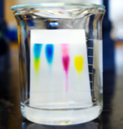 Pulling colours apart
- Paper towel
- Green food colouring or green felt tip pen
- A glass with one inch of water inside
- Tear the paper towel into a long narrow strip.
- Put a drop of green food coloring or draw a circle of green pen about two inches from the bottom of the strip of paper towel.
- Hang the paper towel into the water so that the spot of food colouring is above the water.
- Wait about 15 minutes.
- The original green spot will be gone and a yellow and blue spot should be visible.

As the food colouring is drawn up the paper towel, the different pigments separate. The reason is the pigments are different weights, travel at different speeds, and thus end up in different places. Chromatography is the technique of separating mixtures.

Try different colours.
Try different types of paper.
Try substituting water with vinegar.
Send us a video or a photograph using the Teams assignment.
Please complete your experiment with an adult
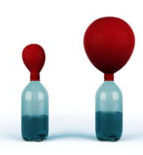
Friday Home experiment 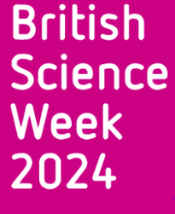

- Two containers – each needs to be big enough to hold a two litre pop bottle
- 2 liter soda bottle
- Ice
- Water
- Balloon
1. Pour one container with hot water from the tap. Please do not use boiling water.
2. Fill the other container with ice and then add cold water.
3. Blow up the balloon and stretch it out to make it flexible.
4. Now, place the stretched out balloon over the mouth of the bottle.

5. Place the bottle in the hot water and watch the balloon slowly start to expand.

6. Now, remove the bottle from the hot water and place it in the ice container. The balloon will deflate and contract.

7. Repeat as many times as you like!
As the air molecules inside the balloon are heated up, they expand and inflate the balloon. In contrast, as the air molecules are cooled, they condense and become more compact and deflate the balloon.
.
Try different sized bottles.
Try different sized balloons.

Send us a video or a photograph using the Teams assignment.
More experiments can be found using this link https://www.sciencefun.org/kidszone/experiments/science-experiments-for-kids/

