
Valley Primary School:
Waves of Teaching
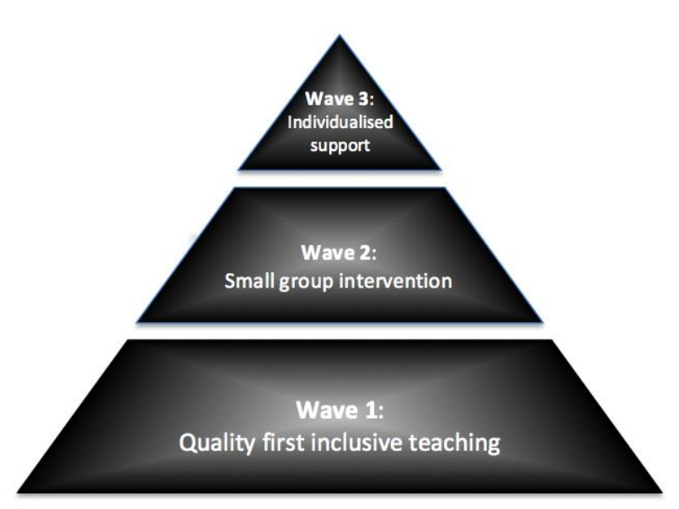

Our provision map is arranged in three ‘waves’ of teaching as outlined in the diagram above. The SEND Code of Practice (2015) states that: “high quality teaching that is differentiated and personalised will meet the individual needs of the majority of children and young people”. This is the Quality First Teaching labelled as Wave 1.
Schools are required to “adopt a graduated approach with four stages of action: assess, plan, do and review”. If at the assessment stage schools determine that a child is not making expected progress they should plan additional provision to help close the gap between the child’s attainment and that of their peers. This may take the form of a small group intervention i.e. Wave 2.
If, when reviewed, it is found that the additional provision has not succeeded in sufficiently accelerating the child’s progress then the provision should be altered. After one or more cycles of review it may be found that the child requires more individualised support at Wave 3. Many children receiving Wave 3 provision will be classified as having a Special Educational Need (SEN). Further details regarding legal definition of SEN and our school’s process for the identification and support of those with SEN can be found in the school’s Special Educational Needs Information Report.

Valley Primary School: Provision Mapping
2022/2023: WAVE 1:
Wave 1 is good quality, inclusive teaching which takes into account the learning needs of all children in the classroom. This includes providing differentiated work and creating an inclusive learning environment. Here are some examples of our Wave 1 provision which will be adapted according to the needs of the children.
Curriculum  - Broad and balanced curriculum.  - Exciting topics with opportunities to be creative and investigative through meaningful Aspires.  - Express outcomes.  - Well-planned, differentiated lessons.  - Use of multi-sensory approaches.  - Focus on developing key skills (power of reading, mathletics, KIRFS, spell seekers).  - Assemblies, trips, visiting speakers and themed days.  - Regular opportunities for contact with parents and carers.  - Home/school communication through reading records and class email.  - Activate. | Pastoral  - Inclusive ethos which celebrates difference.  - Dedicated pastoral staff team to support families.  - Encouraging and nurturing philosophy.  - Staff work to form positive, supportive relationships with children and parents/carers.  - School council to promote pupil voice.  - High expectations of behaviour and effort – house points.  - Opportunities to share work and achievements with a range of audiences.  - Parent liaison email contact.  - Wellbeing scaling.  - Worry jars.
Staffing  - Fully qualified teachers for every class.  - Skilled Teaching Assistants and Higher-Level Teaching Assistants.  - Home School Link Worker to support emotional well-being.  - Qualified Sports Coach.  - Skilled club leaders e.g. Dance Teacher, Science Club Leader, Recorder.  - Pastoral lead and autism specialist.  - ARC – Specific speech and language difficulties.  - Team teach station. | Environment  - Classrooms are organised to encourage independence – Smart Sacks, maths and English table boxes.  - Visual timetables are displayed and updated in each class.  - Learning prompts are displayed on classroom walls.  - Children’s work is displayed throughout the school.  - Classroom rules are displayed and referred to.  - 3B4T, zone board, BLP and Valley Vision displayed in classrooms.  - Named trays and coat pegs.  - Sensory outdoor area for EYFS.  - Outdoor learning provision.
Assessment and Feedback  • Attainment and progress of all children assessed and tracked throughout the year.  • Verbal feedback and quality first marking informs children of their next steps.  • Good communication with parents through informal e.g. at collection time and formal means e.g. at parent’s evenings. | Resources  • Drinking water for hydration to optimise learning.  • Maths resources such as 100 squares, dice, number lines, diennes.  • Learning resources such as writing prompts and word banks.  • ICT Resources e.g. iPads, laptops, sound buttons, Dictaphones, cameras, microphones.  •Varied outdoor areas including trim-trails, sandpit, garden beds, exploration areas, sheltered areas and the field.
Valley Primary School: Provision Mapping
2022/2023
WAVE 2:
Wave 2 is specific, additional and time-limited intervention provided for some children who need help to accelerate their progress to enable them to work at or above age-related expectations. Wave 2 interventions are often targeted at a group of children with similar needs. In some cases, we may take advice from outside agencies to enable us to target the support for children at Wave 2. For this, we will always seek parental consent first.
Cognition and Learning | Communication and Interaction | Social, Emotional and Mental Health | Physical and Sensory
- Additional visual aids/resources.  - Coloured overlays/reading rulers.  - Additional reading, often 1:1.  - Small group targeted support to close gaps in core subjects (eg. Number fluency, spelling, phonics).  - Use of small steps curriculum to plan provision in reading, writing or maths.  - Task boards.  - Precision teaching.  - Pre-teaching.  - Additional assessment by SENCO/outside agencies.  - Targeted adult support in lessons, either for an individual or a group.  - Wize floor.  - Ipad and Laptop provision.  - Homework and uniform adjustments. | - Emotional literacy support through our pastoral team (mindfulness group, zones of regulation group).  - Speaking and listening skills group (often linked to Language Link).  - Personalised visual timetable or ‘now and next’ board.  - Pre teaching of key vocabulary. (using picture cards or Makaton where necessary).  - Dictaphones to record before writing.  - Colourful semantics sentence work.  - Input from top-up SLT service.  - Communicate in print/Widget.  - PECS cards. | - Additional support at break time or lunchtime.  - Friendship circles.  - ‘Meet and greet’ from key adults at transition points.  - Individual reward system.  - Social stories.  - Transition support.  - Support from Home School Link Worker.  - Thrive assessments. | - Carpet spots/cushions.  - Enlarged texts.  - Fiddle tools.  - Chewelley/chew pencil toppers.  - Individual health care plans and risk assessments.  - Fine motor skill groups (Dough Disco and Fizzy Hands).  - Gross motor skill groups (BEAM)  - Sloping board for desk.  - Specialist resources (e.g. lap weights and wobble cushions).  - Targeted adult support.  - Specific seating position in class.  - Use of a laptop.  - Movement breaks.  - Enlarged work.  - Weighted blankets.  - Chair resistance bands.  - Ear defenders.
Valley Primary School: Provision Mapping
2022/2023
WAVE 3:
Wave 3 is individualised provision for a minority of children where it is necessary to provide highly tailored intervention to accelerate progress or enable children to achieve their potential. This may include specialist interventions, a high level of staffing, or the involvement of outside agencies. A SEND Support Plan (NBP) will be developed.

Cognition and Learning | Communication and Interaction | Social, Emotional and Mental Health | Physical and Sensory
- Individual targets recorded and reviewed regularly using Needs Based Plan.  - Intensive support from additional adult.  - Input from specialist teaching service.  - Input from speech and language service.  - Input from educational psychologist.  - Input from early years support service. | - Input from speech and language support (SALT) – 1:1, individual targets.  - Individual visual resources – timetable, task board, phonics mat.  - Input from Autism Outreach Team.  - Use of communication tools such as PECS and Makaton.  - Early Help assessment. | - Targeted social skills work – 1:1 or small group.  - Individual behaviour plan.  - Input from primary behaviour support (Warwickshire).  - Input from specialist outreach services (e.g. Refresh).  - Referral to CAMHS (SOLAR) team.  - Family support worker.  - Boxall profiles.  - EBSN (non-attenders). | - Physical/sensory additional support in class/during PE/lunchtimes.  - OT programme.  - Sensory diet.  - Referral to occupational therapy/physiotherapy/physical and sensory support service.  - Access to specialist equipment (e.g. chairs) as needed.  - Involvement of hearing specialist/vision specialist teacher and adjustments made according to advice given.

Valley Primary School: Provision Mapping
2022/2023
INTERVENTIONS:
The following table details the range of interventions that are currently available in our school:
Area | Intervention | Overview | Length of intervention | Ratio | Adult delivering intervention
Cognition and Learning  Maths | Numicon | Use of concrete resource to support learning | Daily support in maths lessons | Individual work | Teacher
Cognition and Learning  Maths | Use of Ipad | Doodle maths and Topmarks | Daily 5 minute sessions | 1:1 | TA
Cognition and Learning  Literacy | Nessy | Synthetic phonics based programme to support dyslexia and language skills | Daily 20 minute session on ipad | Individual work | TA
Cognition and Learning  Literacy | Read, Write, Inc. | Synthetic phonics programme that ensures early success in reading | Daily 30 minute session | 1:8 | TA/Teacher
Cognition and Learning  Literacy | SNIP | Aimed at increasing reading and spelling and uses the primary high  frequency words (HFW) – for pupils 8+. | Daily 10 minute session | 1:1 | TA
Cognition and Learning  Literacy | Write from the start | Developing fine motor and perceptual skills to develop muscles in hand for handwriting. | Daily 10 minute session | 1:1 | TA
Cognition and Learning  Literacy | Rapid Writing | Designed for children who are not making progress with their writing skills. | Twice a week for 20 minutes | Small groups  (Maximum 5) | TA
 | Write Away Together | Designed for children who are not making progress with their writing skills. | 3 times a fortnight. | 1:1 | TA
 | Colourful Semantics | Therapy technique which uses colour coded cards to help children to learn the important elements of a sentence and how to join them in the correct order. | Flexible sessions | Whole class, group work or individual target work based on need, KS1-KS2 | Teacher/TA
Communication and Interaction | Language Link | Online assessment and intervention package providing support for children with language difficulties. | Initial assessment (20 minutes) 1:1 and then 30 minutes weekly. | Small groups (Maximum 6) | TA
Communication and Interaction | NELI | Early language intervention for year R children. | 20 week block programme – 40 minutes daily | Small group (Maximum 6) | TA
Communication and Interaction | Time to Talk | Develop social interaction skills and improve oral language skills. | 20 minutes, 2-3 times a week | Reception-Year 2 | TA
Emotional, Behavioural and Social | Zones of Regulation | Visual system used to control emotion-driven behaviours by managing overwhelming emotions. | Weekly 30 minute session | Small group (Maximum 5) | Pastoral lead
Emotional, Behavioural and Social | The Big A | Individual intervention to help newly diagnosed children to understand their autism skills. | Weekly 30 minute session | 1:1 | Pastoral lead
Emotional, Behavioural and Social | Mindfulness | Small group work to develop calming strategies to manage big emotions. | Weekly 30 minute session | Small group (Maximum 6) | Pastoral lead
Emotional, Behavioural and Social | Karen Treisman therapeutic treasure deck | Use of feelings cards and sentence completion cards to offer support with anxiety/self-esteem/bereavement/trauma through fun, non-threatening activities. | Weekly 20 minute session | 1:1 | Pastoral lead/TA
Sensory and Physical | BEAM | Structured PE programme to develop early motor skills. | Weekly 1 hour session for 6 weeks | Whole class or individual, based on need | Teacher/TA
Sensory and Physical | Dough Disco | Programme involves moulding dough to music, performing different actions to strengthen fine motor skills. | Daily 5 minute session (children in nursery and reception) | Small group (Maximum 6) | Teacher/TA
Sensory and Physical | Fizzy Hands | NHS level 1-3 programme to develop skills in balance, body awareness, co-ordination and fine motor skills. | X3 weekly 20 minute session. | 1:1 | TA
Sensory and Physical | Squiggle whilst you Wiggle | Uses dance and large movements to help children develop fine muscle control needed for writing. | 3 minutes daily | EYFS – whole class or individual, based on need | Teacher/TA

