
Valley Primary School

GROWING AND LEARNING TOGETHER TO BE THE BEST WE CAN BE !
ASPIRE…ENJOY…ACHIEVE…CHALLENGE !

Head Teacher: Miss S. Milewski

explorers@valleyprimary.org Tel: 07850 928320
Old Lode Lane, Solihull, B92 8LW Middle Phase (Y2, Y3) and Upper Phases (Y4, Y5, Y6)
Fallowfield Road, Solihull, B92 9HQ Lower Phase (Nurs, Rec, Y1)
Contract between Parents/Carers and Valley Primary School Explorers
2026-2027

Valley Explorers is operated by Valley Primary School across two sites.

Fees
- Fees are payable in advance as notified in writing, fees not paid on the due date as stated on the invoice may incur a non-payment charge of £5.00 per week the invoice remains outstanding.
- The office has the right to issue a formal warning to the parent/carer and inform them that continued late payment will result in their child’s place at the club being forfeited.
- No fees are payable outside the school term time, for bank holidays in school term time, or for school inset days if you do not require the service.
- Care in addition to contracted hours, will be charged at the non contracted rate per hour or part thereof. Collection after 6.00pm will incur a charge of £10.00 per 5 minutes.
- You as the signatory to this contract are responsible for paying your fees on time, and it will be a breach of this contract if fees are not paid by the due date.
- Full fees are payable throughout the school terms, when the club is open. This includes contracted sessions when the child does not attend due to bad weather, illness, holidays and unforeseen circumstances.
- Unforeseen circumstances: Should Valley Explorers need to close due to unforeseen circumstances (such as in the event of a national pandemic or due to a boiler breakdown), the club must ensure this does not impact on the sustainability of the club by allowing staff to be paid. Should the club need to close for more than 5 days, fees will be charged at 50% for the remaining period of closure and be reviewed after 4 weeks, with parents notified in writing.
- Illness of child/suspected contagion symptoms: If the child does not attend club due to a suspected or confirmed contagious illness as listed within the school policies, full fees will be charged during the time they are not permitted to attend club.
- Bad weather/ property maintenance/ health and safety concerns: Should Valley Explorers need to close due to adverse weather or health and safety concerns for up to a period of 5 days, fees will still be payable during the closure period.
- A £30 Half term discount will be applied for any child accessing both before school care and after school care long sessions every day.
- Sessions may not be transferred and no refunds will be given for non-attendance at Explorers.
- No food or drink will be provided. Children are welcome to bring a packed drink and snack.

Arrivals and Departures - The club operates Monday through Friday from 7.30am to 6.00pm. Parents are asked to please collect their children upon or before 6.00pm. We are not insured to care for the children after this time and therefore will not be covered for any accident or incidents. Any parent picking up their children after 6pm will be charged £10.00 per 5 minutes. If a parent/carer knows that they will be late they are asked to notify the club. Repeated late arrival will be a breach of this contract and may lead to exclusion from the club.

Under normal circumstances, your child will not be allowed to leave with anyone who is not documented on our contact list.
Therefore, should you wish someone else to collect your child, it is necessary for you to inform the club in advance. If you are unavoidably delayed, you must telephone and speak to the Valley Explorers Team who will make specific arrangements with you. The password system will then come into operation.

Parking at Explorers - At Valley Primary School, we take the safety of both our children, staff and site users very seriously. We kindly ask for the support of parents and carers in helping us maintain a safe environment. Our school entrances and car park areas present challenges that require extra care and attention.
Whenever possible, we encourage walking to school. If driving is necessary, please note that at Old Lode Lane, the main car park directly outside the Explorers building should not be used for dropping off or picking up children from before or after school club. Additionally, parking on the pavement in front of the school is strictly prohibited, as it creates a hazardous situation for school entrance and exit.
At Old Lode Lane, parents are asked to use the visitor’s car park as marked on the map below.
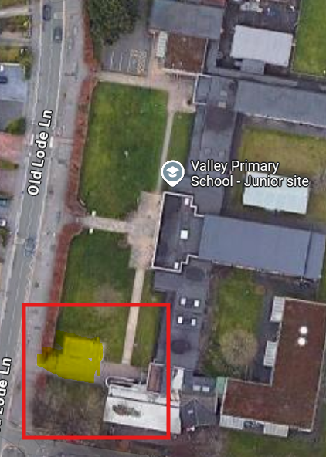

At Fallowfield Road, we ask that parking within the car park close to the Explorers gate is within parking bays only so as not to block vehicular access. We also ask that approach up and down the driveway is made slowly with extreme caution and with courtesy to other vehicle users entering / exiting the site.
Please be reminded the last drop off time for Explorers on both sites is 8.15am and the earliest collection is 3.45pm. This is to avoid school drop off and collection times.
On Fallowfield Road however, due to the School Streets scheme which is in operation, it is not possible to drop a child off by car after 8am so any children arriving between 8am -8.15am will need to enter through the pedestrian entrance.
We reserve the right to revoke a child’s place at Explorers with immediate effect if these rules are disregarded. Thank you for your cooperation in ensuring the safety of all members of our school community.

Note: Should unfavourable domestic issues arise, please resolve the matter of collecting your child as Valley Explorers cannot legally prohibit any parent from collecting their child – unless there is legal documentation to state otherwise.

Absence/Holidays - We would appreciate as much notice as possible if your child is not going to attend sessions, including notice of holidays. It is also essential that parents inform staff of their child’s attendance at a school led club.

Responsibility - Whilst all reasonable care will be taken, Valley Explorers cannot take responsibility for loss or damage to clothes or any other property bought into club. Clothes and all other property should be marked with your child’s full name.

Safeguarding Children – Valley Primary School Explores abides by the school’s Safeguarding and Child Protection Policy. As with all child carers, our organisation is obliged to report any concerns about the welfare of children. Staff members have the obligation to report concerns included in their contract of employment.

Policies – Valley Explorers abides by all school’s policies; copies of which are available from the school office, or the school website. Information provided on the data collection sheets and parental consents will be shared between Valley Primary School and Valley Explorers should your child attend the provision.

Valley Primary School is a proud member of The Elliot Foundation MAT and therefore Valley Explorers abides by all MAT values and principles.

DECLARATION BY THE PARENT/CARER:-
I confirm that I have read and agreed the information above and understand this document constitutes a legal contract for Valley and that both parties are bound by its provisions.

Contract agreed by Parent/Carer

Signature …………………………………………………………………. Name ……………………………………..……………………… Date ……………………………………..……

