SEND Information Report


2026-2027

Reviewed in June 2026 by Alex Heaven (SENDCo)

Our School   | Our School Vision  Valley Primary School is committed to the inclusion of all children including those with Special Educational Needs. We pride ourselves on the philosophy that students are recognised as individuals, each with their different strengths, difficulties and individual learning styles. We welcome all children and foster an ethos which celebrates children’s differences and the talents of all. We believe that every child is unique and each and every one of our children has something very special to offer our school community.  A child has special educational needs if they have a significantly greater difficulty in learning than the majority of children of the same age, or if they have a disability which prevents or hinders them from accessing the curriculum provided in school. We are committed to providing high quality education for all pupils with Special Educational Needs and Disabilities (SEND). We have strong systems for the early identification of pupils with SEND and always welcome and work in partnership with parents and carers. We have dedicated SEND leaders in place and endeavour to provide high quality and innovative resources, support and challenge to children with specific educational needs or a specific disability which may impact on their learning. We aim to ensure all pupils aspire for excellence and have the opportunity to reach their full potential. We foster a positive, inclusive & nurturing environment.  June 2026 Information  Valley Primary currently has 566 children on role (June 2026).  There are currently 114 children on the SEND register (including 16 children with EHCP status) with a range of needs.  41 children have a specific diagnosis of need.  9 children have a significant and complex need that requires specialist support and are awaiting placement in a specialist setting.  74 children are on the monitoring register (targeted support).
  Meet our SENDCo Team | The SENDCO is Mrs Sarah Wood. Assistant SENDCo is Miss Laura Kelly.  If you would like to contact Mrs Wood or Miss Kelly, please call  school on 0121 743 4691 or email send@vallyprimary.org .

Who are the best people to talk to if I have a concern about my
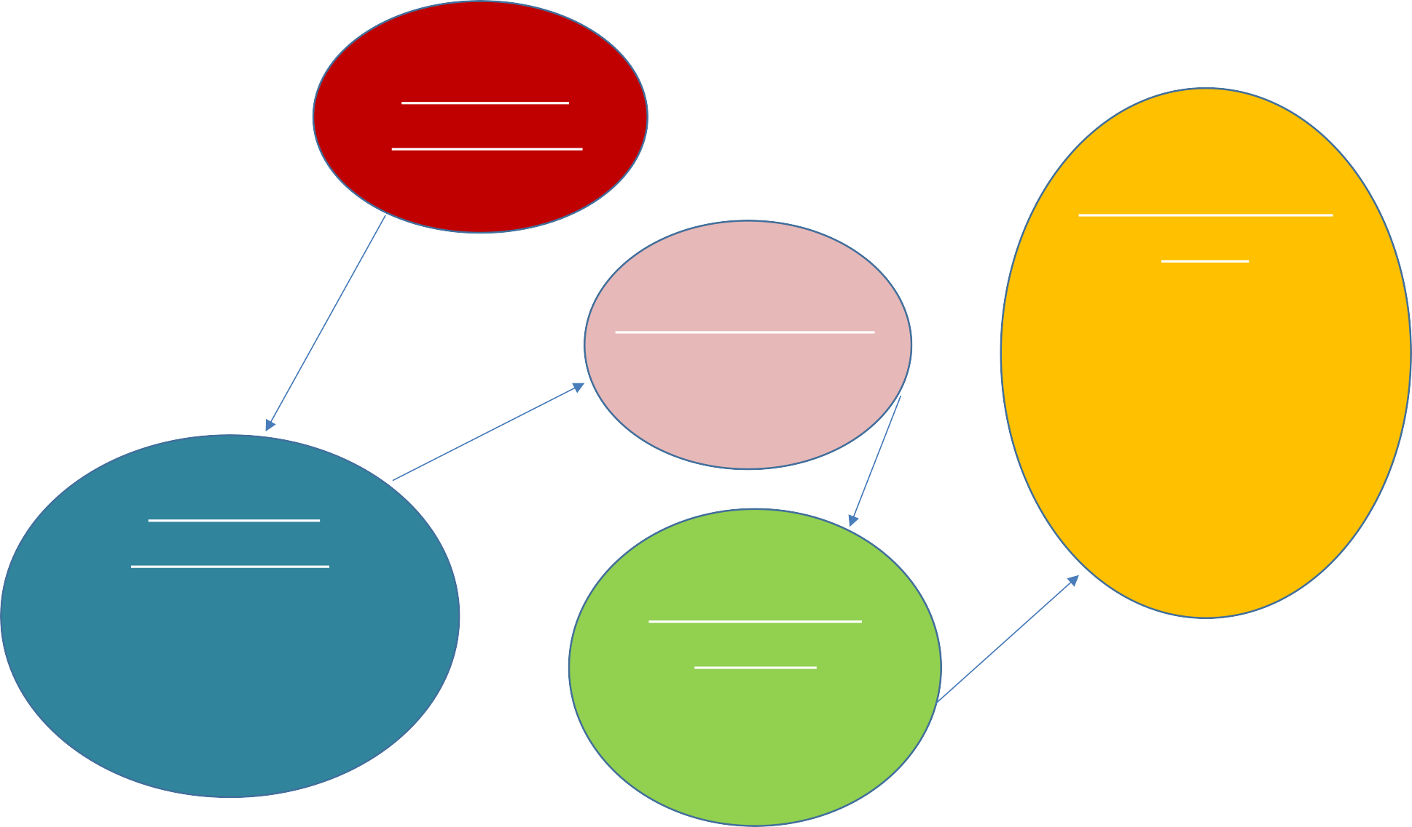

child?

Parent
Liaison
Miss Freeborn
Your Child’s
Class Teacher

Assistant SENDCo: Miss Kelly

Inclusion Lead/
SENDCo:
Mrs Wood

Senior Leadership
Team:
Miss Milewski Mrs Wilton Mrs Wood Mrs Burgess

Reviewed in June 2026 by Alex Heaven (SENDCo)

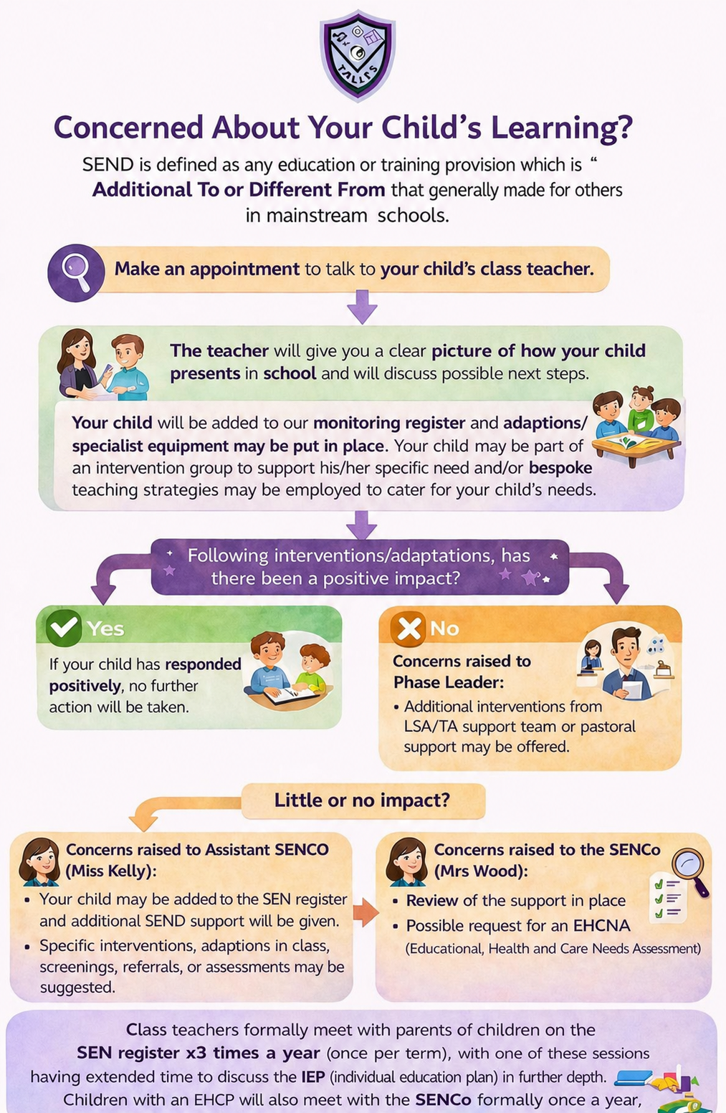

SEND at Valley Primary School
Our school is an inclusive school where every child is catered for every day; we aim to address children’s needs and support their development in the most appropriate way possible and celebrate effort as much as achievement. Our school’s SEND policy document is available on this website, detailing our philosophy in relation to SEND. Additional and/or different provision is currently being made in school for children with a range of needs, including:
Cognition and Learning:
Dyslexia Moderate Learning Delay
Executive Functioning Difficulties

Dyscalculia
Some children find learning more difficult than others. They may need:
- help to break down new learning into smaller chunks of information.
- more time to think about their answers and learn new things.
- information to be repeated and put in different ways.
- help to remember information during a lesson.
- whole class, small group and/or individual support.
- specialist learning approaches/strategies to support specific learning difficulties.

Communication and Interaction:
Some children may need help to play and talk to other children and adults. They may need help:
Autistic Spectrum Disorder Selective Mutism
Developmental Language Disorder

Pre-Verbal Communication
- to understand what others are saying
- talking and listening to others.
- with how to say words and sounds.
- to cope with new things like different sounds, smells and school life.
- with change and how to deal with it.
- to understand the meaning of new words, especially in their learning.

Social, Emotional and Mental Health difficulties:
Some children may need help to play and talk to other children and adults as they find it difficult to manage their own behaviours and cope with their feelings. They may need help to:
- understand and follow school rules.
Attention Deficit Disorder Attention Deficit Hyperactive Disorder
Attachment Disorder High Levels of Anxiety
- understand dangers and keep themselves and others safe.
- listen to and follow instructions.
- understand and manage their feelings.
- make and keep friends.

Reviewed in June 2026 by Alex Heaven (SENDCo)

Sensory and/or Physical Needs:
Some children with disabilities can find it difficult to move around the school safely and may need specialist help with their learning. They may need:
- help with their sight and/or hearing.
Visual Impairment Hearing Impairment
Multi-Sensory Impairment Physical Disability Dyspraxia/DCD
- help with moving around the school building safely.
- specialist equipment such as wheelchairs, walking frames and seating.
- changes to the curriculum such as adapted PE equipment and different ways of recording writing.
- help with medical needs and medication.
- individualised plans for fire evacuations.

SEND pupils at Valley have a wide range of needs. Provision is focused on the child and supported by information and guidance from professionals.

Few pupils
Specialist
SEN support/intervention
for
children with identified Special
Educational Needs.
Some pupils
Targeted
Support/Intervention for children to 'plug their gaps'
All pupils
Universal
Quality First Teaching for all pupils
Ordinarily Available Provision

How will school staff support my child?

Reviewed in June 2026 by Alex Heaven (SENDCo)
Level of support

How do we identify and assess pupils with SEND?
Class teachers will monitor their pupil’s progress against national and school expectations. If concerns are raised about the rate of progress, communication and interaction, health and well-being, safety or behaviour of a child then informal discussions with parents and carers and the class teacher will be instigated. The class teacher will inform the SENDCo. The kinds of special needs and disabilities under the code of practice are as follows:

 | UNIVERSAL | TARGETED | SPECIALIST
Area of need | All pupils, where appropriate | For some pupils | For a few pupils
Cognition and Learning   | - Quality first teaching  •Differentiated planning -activities, delivery and expected outcomes  •Read Write Inc Programme  •Numicon in Early Years and Key Stage1  •Writing frames  •Writing mats: keywords, sounds, checklists  •Reading books for all ages and abilities | - Additional visual aids/ resources.  - Coloured overlays/reading rulers.  - Additional reading, often 1:1.  - Small group targeted support to close gaps in core subjects (eg. Number fluency, spelling, phonics).  - Overlearning opportunities.  - Use of small steps curriculum to plan provision in reading, writing or maths.  - Task boards.  - Now/Next boards.  - Precision teaching.  - Pre-teaching.  - Additional assessment by the Inclusion Team: Screening Tools – GL Assessment (Dyslexia), British Picture Value System (BPVS), Sandwell (Early Maths), YARC (Early Reading).  - Targeted adult support in lessons, either for an individual or a group.  - Ipad and Laptop provision.  - Homework adaptations. | - Specialist English and Maths programmes, e.g. Write From the Start, Nessy, Number Stacks, Core Words.  - Colourful semantics sentence work.  - 1:1 Tuition, precision teaching.  - Alternative core skills curriculum.  - Auditory and visual memory groups.  - Input from Early Years support service.  - Input from Educational Psychologist.  - Input from Specialist Teaching Service advice.  - Individual targets recorded and reviewed regularly using Individual Education Plan.

Reviewed in June 2026 by Alex Heaven (SENDCo)

Communication and Interaction   | - Quality first teaching.  - Differentiated planning – activities, delivery and expected outcomes.  - Structured school and class routines.  - Language for learning principles – Visual timetables, key words displayed using communication in print (Widgit).  - Explorers (Breakfast club/After School Club) provision. | - Speaking and listening skills groups (Language Link and WellComm).  - Personalised visual timetable.  - Now and Next board.  - Pre teaching of key vocabulary. (using picture cards or Makaton where necessary).  - Communicate in print/Widgit word banks.  - Talking Tins/Dictaphones to record before writing.  - Total Communication Environment.  - Individual Vocabulary Book.  - Additional assessment by the Inclusion Team: Screening Tools – Wellcomm (Early Years), Language  Link (KS1 and KS2), British Picture Value System (BPVS). | - Speech Therapy intervention.  - Core Word intervention.  - Chatty Chums/Social Circle intervention.  - Input from Autism Outreach Team.  - Input from Speech and Language Therapy Service.  - Input from Early Years Team.  - Input from Educational Psychologist.  - Input from Specialist Teaching Service advice.  - Communication Boards.  - PECS.
Social, Emotional and Mental Health   | •Quality first teaching.  •Differentiated planning -activities, delivery and expected outcomes.  •Behaviour policy.  - Zone Board.  •School/class rewards and sanctions Systems (Golden Tickets, House Points).  - Pastoral/Behaviour Support Team in school.  •Play leaders.  - Explorers (Breakfast club/After School Club) provision. | - Additional support at break time or lunchtime.  - Friendship circles.  - ‘Meet and greet’ from key adults at transition points.  - Individual reward system.  - Social stories.  - Transition support.  - Sensory Room access.  - Support from Family Support Worker.  - Additional assessment by the Inclusion Team: Screening Tools – Boxall assessments (Nurture Provision). | - Targeted social skills work – 1:1 or small group.  - Emotional literacy support (Mindfulness, ELSA, Zones of Regulation).  - Individual behaviour plan.  - Individual risk assessment.  - Input from Specialist Teaching Service.  - Input from specialist outreach services (e.g. Alternative Provision Referrals).  - Referral to CAMHS (SOLAR) team.  - Family Support Worker.  - Ordinary Magic intervention.  - Early Help assessment.
Reviewed in June 2026 by Alex Heaven (SENDCo)

Physical and Sensory   | •Quality first teaching.  •Differentiated planning -activities, delivery and expected outcomes.  •Staff awareness and training for implications of physical impairments.  •BEAM/MOVES strategies in EYFS PE lessons.  - Activate.  - Yoga Bugs. | - Individual health care plans and risk assessments.  - Pica risk assessment.  - Carpet spots/cushions.  - Enlarged texts.  - Fidget tools.  - Chewellery/chew pencil toppers.  - Sloping board for desk.  - Specialist resources (e.g. lap weights and wobble cushions, alternative exercise books, chunkier and darker pencils).  - Targeted adult support.  - Specific seating position in class.  - Use of a laptop.  - Movement breaks.  - Enlarged work.  - Weighted blankets.  - Chair resistance bands (Theraband).  •Ear defenders.  - Sensory room access.  - Additional assessment by the Inclusion Team: Screening Tools – Sensory Screening tool. | - Physical/sensory additional support in class/during PE/lunchtimes.  - Occupational Therapy programme (1:1 target support).  - Sensory Circuits intervention.  - Physio Tools resources (NHS).  - Fine motor skill groups (Dough Disco and Fizzy Hands).  - Touch Typing intervention.  - Gross motor skill groups (BEAM/MOVES).  - Input from Occupational Therapy.  - Input from Physiotherapy.  - Input from Physical and Sensory support service.  - Access to specialist equipment (e.g. adapted chairs).  - Involvement of Hearing Impairment specialist/Vision Impairment specialist teacher and adjustments made according to advice given.

Reviewed in June 2026 by Alex Heaven (SENDCo)

At Valley Primary, we work closely as a team and if staff have a concern about a child, a meeting will be held between the class teacher and parent. Adaptions in class may be put in place.


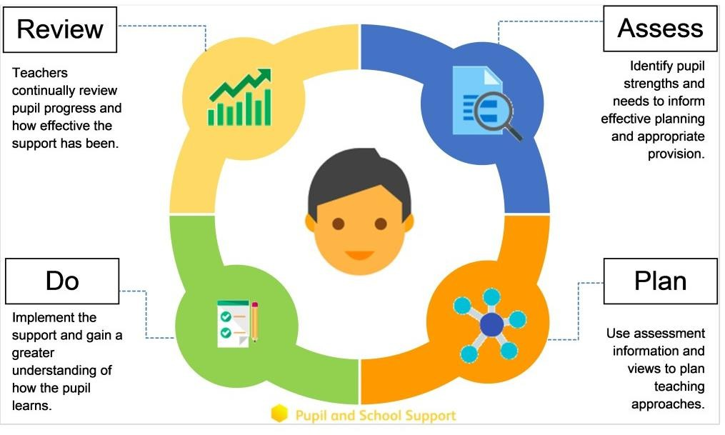

Identifying and Assessing Need
If there has been little or no improvement, the class teacher will escalate support to the Phase Leader. They may implement targeted intervention support from the HLTA team.
If there has still been little or no improvement, the class teacher will fill in an Inclusion Support form. The child will then be placed on the monitoring register and we begin to follow the Graduated Response approach of ‘Assess, Plan, Do and Review’ which will be overseen by Miss Kelly (Assistant SENDCo).

After a period of 6 – 8 weeks, we will decide if a child needs to be placed on the SEND register and invite you in for a meeting where we will share the targets your child is working on and the support they are receiving. An Individual Education Plan (IEP) and Pupil Passport will be created and shared with you, documenting your child’s termly targets and support.
Some children will be monitored using the Cherry Garden Branch Maps or Mosaic Continuum which allows the children who are working at ‘below key stage standards’ to have small step targets set in lessons to allow them to achieve and begin to work independently.

Some children may require more support than is ordinarily available and we may ask outside agencies to support us in ensuring that we are offering the best support we can.
If there is still little or no improvement, having implemented external professional advice and internal adaptations and intervention, Miss Kelly will escalate your child’s support to Mrs Wood (SENDCo) who may discuss the need to request an Education, Health and Care Needs Assessment (EHCNA) from the Local Authority.

  Our approach to teaching children with SEND | We are an inclusive school. Wherever possible children are taught alongside their peers in flexible teaching groups.  Teachers adapt their high-quality teaching to cater for their pupils’ needs and plan individual timetables where necessary. When appropriate, staff are deployed to give children additional interventions in small groups outside the classroom, or to provide one-to-one support.  We use the EEF guidance ‘Five-a-day’ and embed the key principles into all our lessons.  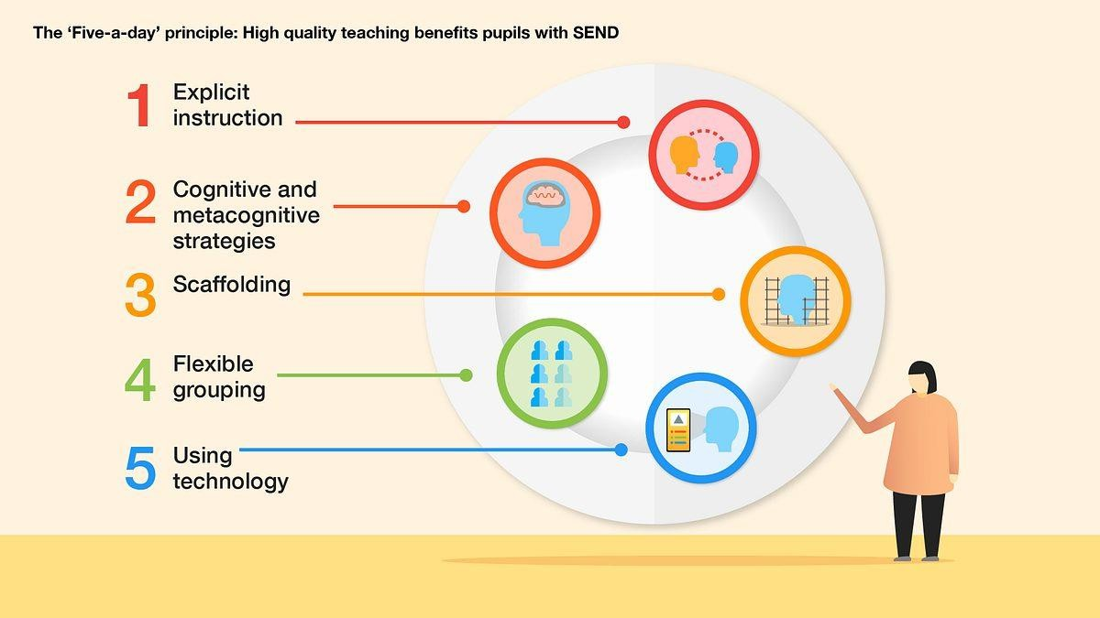  We use the Ordinarily Available Guidance produced by the Local Authority to complement our teaching (January 2024).

  Parent Consultations | At Valley Primary School, we work closely with parents and carers and recognise that they have much to contribute to our support for children with SEND. At the start of every academic year, a ‘Pupil Passport’ is sent home for parents to complete about their child’s needs, preferences and support strategies.  Class Teachers meet with parents three times annually, with an offer of an additional extended parents evening slot once a year for parents with a child who is on the SEN register, where the child’s IEP can be discussed in further depth.  We also hold three coffee morning a year where parents can meet up and support each other in a safe environment. During these sessions we gather parent feedback on SEN provision at Valley Primary School, direct to training courses and support groups and offer opportunities to meet up with outside agencies. We also aim to offer virtual parent workshops at least once a term.  During the year a parental questionnaire is sent out to gain views on the school and the SEND provision.  We particularly welcome information from parents about how their child learns best in order that it can be shared with those people who teach the child.

Child Consultations | Pupil’s views are very important; they have a right to be involved in decisions about their education and they are made aware of the support that surrounds them in school.  Children are fully involved and their views feed directly into all policies, procedures and daily teaching of children with SEND.  Pupils are given regular opportunities to:  Self-assess how they Attend meetings and Feedback and Review are doing help decide the progress/interventions.  support needed.
  Evaluating Provision | Review progress in Senior Leadership Team meetings and discussing next steps.  Discuss and share ideas in staff meetings to ensure up to date research and policy is in place.  Reviewing children’ individual progress towards their goals at regular intervals, as a minimum every term.  Establishing children’s baseline before receiving interventions and reviewing the impact of interventions at regular intervals.  Asking our children if they feel the adjustment or intervention is helpful and makes a difference.  Monitoring by the SENDCo and Assistant SENDCo.  Regularly using a tracking tool to update targets and measure progress. Holding termly reviews for children who are on the SEND register.  Holding annual reviews for children with Education Health Care Plans.
  Staff Training | At Valley Primary, we believe in professional development and aim to ensure all our staff have the understanding they need to enable them to support your child.  When a new member of staff joins the school, we ensure they understand the systems within school and they are given information about the children they are working with.  Every classroom has a ‘Class Headlines’ folder on the back of the classroom door which details the needs of the children in the class and individual strategies and support information.

 |  | 

Staff Training | The Senior Leadership Team within school are constantly moderating needs within the school and, where an area of concern is highlighted, whole school training could be organised to ensure all staff understand specific learning difficulties and appropriate teaching or support strategies that could be utilised.  If your child needs specialist support from an outside agency, such as the Speech and Language Service (SALT), Educational Psychologist (EP), Occupational Therapist (OT) or school nurse, we will always discuss this with you first.  Some of our staff have completed training in the following areas. When staff go on a course, they have an opportunity to give feedback to the rest of the staff during staff meeting sessions.

 |  |  | 
Play Therapy | Lego Therapy | Child Development | Bucket time
 |  | 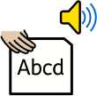 | 
Making Sense of Autism | Makaton | Read, Write, Inc.  Phonics | De-Escalation Strategies
 |  |  | 
Specific  Learning Difficulties | Complex Needs training | Nurture support | Speech and Language
 |  |  | 
TEACCH  Workstation | Attachment and Trauma Training | Reading for those who struggle | Sensory Needs

Staff Training | Valley Primary School employs a SENDCo (Mrs Wood).  Valley Primary also employs an Assistant SENDCo (Miss Kelly) who is currently completing the NPQSENCo qualification.  Valley Primary has a Family Support Worker (Miss Lambert) and an Emotional Literacy Support Assistant (ELSA – Mrs Ford).  Valley Primary also has a team of Learning Support Assistants, Teaching Assistants and Higher Level Teaching Assistants (HLTAs) who are trained to deliver a range of evidence-informed interventions on a small group and 1:1 basis e.g. Language Link, Precision Teaching, Number Stacks, Zones of Regulation, Chatty Chums, Memory Magic and Blanks Language.  -There are first aid trained members of staff on both of our sites.  -Staff are trained by the School Nurse Team with regards to asthma, anaphylaxis and epilepsy.  -Whole staff training has also been received, delivered by specialists, in relation to Autism in girls, Developmental Language Disorder, Working Memory Difficulties, Hearing Impairment and Attachment difficulties.  Valley Primary have four practitioners with Language Link accreditation, three practitioners with training in Adverse Childhood Experiences, two practitioners who have received specific training on supporting children with physical needs, one practitioner who holds the ELSA (emotional literacy support assistant) qualification and four practitioners who have received Makaton and Attention Autism training.  All staff have received specialist training from the Autism Team for the understanding and use of the Autism Education Trust (AET) framework.  All staff in our school have completed at least 3 modules of the Dingley’s Promise training. As a result, we received an Inclusion Award in June 2026 as a reflection of our inclusive values and high levels of staff knowledge.  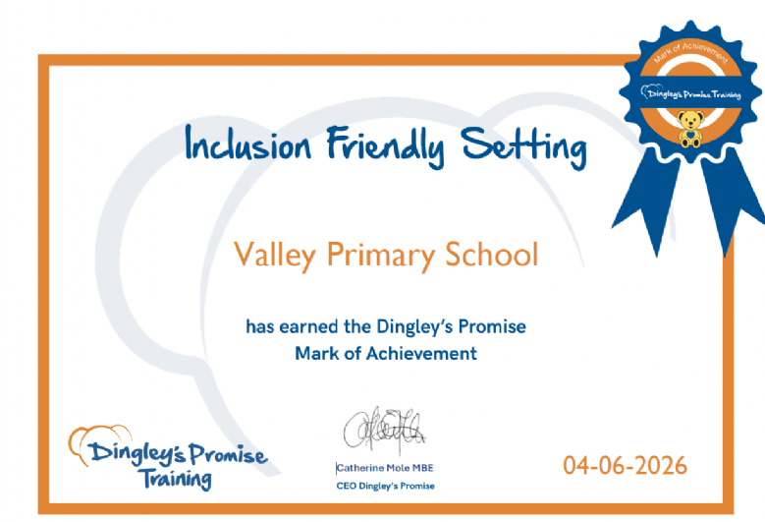

  Transition Support | Nursery to Reception  We hold a parent and carer session in the summer term for our new reception starters, providing parents with the opportunity to meet with the class teacher and SENDCO.  We hold two ‘taster’ sessions follow in the second half of the summer term in preparation for their September start.  Transition to Reception, and then into each successive year-group, is supported by meetings, information leaflets and taster sessions in each new class.  End of Year transition  When children move up a year, we can provide transition sheets which include photos of the teacher and classroom environment.  We hold a transition session during the summer term allowing the children to go up to their new classroom and meet their teacher.  Some children may require extra transition visits to their new classroom to help reduce their anxiety and ensure that the transition is successful and positive.  Class teachers meet with each other during the summer term to discuss the needs of the children and share Individual Learning Plans.  Secondary Transition  We liaise very closely with our partner schools to ensure that the transition from primary school to the secondary school is as smooth as possible.  Mid-Year new starters  When we are aware that pupils joining us from other settings have identified special educational needs, we arrange a meeting with the family to enable us to gain a greater understanding on the support we need to put in place.
  Outside Agencies | We work with the following agencies to provide support for children with SEND:  Warwickshire Specialist Teaching Service SISS Autism Inclusion Team  Solihull Educational Psychology Service, School Nurse Health Advisory Service, Speech and Language Therapy, Occupational Therapy,  SOLAR,  Visual and Hearing Impairment Team, CSAWS (Attendance).  We will ask your permission before we arrange for any outside agencies to come in and work with your child.  Once the feedback has been received, we will call you in for a meeting to share the advice.
Assessment and Screening Tools

Assessment and Screening Tools | In order to understand a child’s learning difficulties in more detail, we may use screening/assessment tools, including:  -Wellcomm (Early Years Language)  -Language Link (Key Stage 1 and Key Stage 2 Language)  -Read, Write, Inc. (Phonics)  -Early Reading (YARC)-Diagnostic Reading Analysis  -GL Assessment (Dyslexia) Screening  -Sandwell (Early Numeracy Skills)  -British Picture Value System (BPVS)  -Boxall (Nurture) Profiles  -Visual Stress Screening  Other specialised assessments which may be used in school to identify barriers to learning include:  -Social, emotional, behavioural checklists  -Strengths and Difficulties Questionnaire  -Observation schedules e.g. for behaviour, concentration, attention.  -Assessment of Hand and Fine Motor Skills  -Gross Motor Assessment Checklist.  We will always seek parental consent before conducting any screenings or assessments named above.  We assess the outcome of short term targets that have been set using the in-school assessments systems such as Arbor, Mosaaic Continuum and Cherry Garden Branch Maps when reviewing your child’s Individual Education Plan.  To evaluate the success of specific targeted intervention, we use provision mapping – all of our interventions are evidenced informed. Outside agencies may check that support is working by conducting specialist assessments before support starts and then after give a clear picture of the progress made.  Your child’s progress is continually monitored by his/her class teacher. Your child’s progress is reviewed formally every term and an assessment is made in reading, writing and mathematics in relation to the National Standards.
  Clubs and Trips | All of our extra-curricular activities and school visits are available to all our children, including our before-and after-school clubs.  All children are encouraged to go on our trips such as residentials, visits to locations linked to our topic curriculum and overnight stays. All children are encouraged to take part in sports day, school competitions, school assemblies and performances, workshops, etc. All children are encouraged to apply for roles of responsibility in school e.g. school council, playground leads, eco-warriors, digital ambassadors etc.  No child is ever excluded from taking part in these activities because of their SEN or disability.  Please read the school’s accessibility plan for further information about the steps we have taken to prevent disabled children from being treated less favourably than other children and the arrangements we have made to help children with SEND access our school.

Adapted Equipment | We identify necessary adapted equipment through discussion with parents and any specialist teams who are supporting a child.  Equipment and facilities to support children with SEND are non-negotiable at our school – we aim to provide any equipment or adjustment necessary to support the needs of a child with SEND e.g. an area of quiet retreat; provision of coloured overlays; provision of equipment e.g. sensory cushion and implementation of strategies e.g. brain breaks for children with sensory issues.  We regard our duty to make reasonable adjustments as an anticipatory duty –i.e. it applies not only to disabled children who already attend our school but also to disabled children who may attend in the future (this does not imply that we anticipate every possible auxiliary aid and service that may be required by current or future children attending our school, but that we anticipate those auxiliary aids and services which it would be reasonable to expect may be required).  Auxiliary aids could include for example the provision of a piece of equipment; additional staff assistance for disabled children; readers for children (and adults in our school community) with visual impairments.  Our school’s Accessibility Plan, available on request in school outlines adaptations made to the building to meet particular needs and enhance learning.
Parent Support | Special Educational Needs and Disability Information, Advice and Support Service (SENDIAS):  A service for parents of children with Special Educational Needs. Their aim is to enable parents/carers to make informed decisions about their child’s education, by ensuring they have the advice, information and support to make those decisions. https://www.family-action.org.uk/solihullsendias/ Telephone: 0121 516 5173  SASSI Solihull:  SASSI is an Autism Support Group for parents/guardians of children or young people with an autistic spectrum disorder. All are welcome whether there has been a diagnosis or there is one pending. We offer a social opportunity to talk to parents in the same situation and an opportunity to talk informally to a variety of professionals. http://www.solihullsassi.co.uk Telephone: 0121 770 6267  SEND National Advice Service:  Advice and information for families whose child may have special educational needs. Telephone helpline: 0808 808 3555.  Opening hours: Monday to Friday 9.30am to 5.00pm

Parent Support | Signpost Inclusion:  Parent to parent support offering groups and drop in sessions in a friendly environment. Early Support Training and capacity-building. There is a growing resource base with books and sensory resources. Signposting to relevant services. info@signpostinclusion.org.uk  Telephone: 07534 352 754  National Parent Partnership Network:  Supports all parent partnership services across England. NPPN works under the guidance of the Council for Disabled Children and is funded by the Department for Education Tel: 0207 843 6058  Carers UK:  The voice of carers and is the only carer-led organisation working for all carers. Carers Line: 0808 808 7777  The Solihull ‘Local Offer’ tells parents and young people what they are entitled to, what services are available and how to access them. Solihull Local Offer | Solihull Metropolitan Borough Council
Parent Feedback | “Thank you for your time and help, you truly are a wonderful SEND and Pastoral Team”  “Communication is much better. Knowing my daughter is looked after SEN wise is amazing. You have boosted F’s confidence so much this year, thank you.”  “They care, they listen and are prepared to take on board what parents say and work collaboratively for the good of the children and families.”  “Your dedication to all the children is unbelievable. You worked tirelessly to get F his EHCP and you have never stopped. The help, aids and support you have provided have been more than I thought. I had a bad experience many, many years and I was so scared when F started but you have completely changed my thoughts. For that I will be forever be grateful!  You never make me feel silly for asking anything and allow me have an input and most importantly you listen to me and all the parents that you work with. For that, thank you. The school is so lucky to have someone who cares so much for each child.”

Compliments and Complaints | At Valley Primary School we have a strong commitment towards working in positive partnership with the whole community. Our ethos respects the rights of all members of the school community. We acknowledge that from time to time, something may go wrong. Where any concerns are raised we aim to resolve these as quickly and as efficiently as possible. As part of the Concerns and Complaints Policy (see School Policies, TEFAT Trust Wide Policies), we hope that concerns that are raised can be resolved very quickly by simply contacting the member of staff or the Parent Liaison Lead, who will investigate and respond to you as soon as possible.  Should resolution not be achieved when you raise a concern at the informal stage, this then becomes a complaint and we ask that you complete the formal complaints form below and return this to the Parent Liaison Lead who will escalate your complaint appropriately.  Our Parent Liaison Lead, Miss Freeborn, would be happy to hear from you and discuss any concerns, queries or complaints. She can be contacted on:  parentliaison@valleyprimary.org  Should you be unable to resolve your complaint at the informal stage, please see the complaints policy and follow the escalation steps using the form below:  The Elliot Foundation Academies Trust  Compliments  We also welcome parents and carers to provide us with positive feedback about the school or members of staff who deserve recognition. Share the details with us and we'll make sure your compliment gets back to the right person or team. To do this, please complete and return our compliments form to the Parent Liaison Lead.  Our Parent Liaison Lead, Miss Freeborn, would be happy to hear from you and discuss any compliments. She can be contacted on:  parentliaison@valleyprimary.org
You Said, We Did | - You said you would like more feedback in regard to how your child is doing following an intervention.  We have updated our Individual Education Plan (IEP) format which now has specific detail about intervention entrance and exit data, as well as  commentary about individual progress.



You Said, We Did | - You said you would like suggestions of interventions sooner.  We have updated our Provision Map (see website) with details of our intervention offer. These can be discussed at anytime with your child’s class teacher.  - You said you would like more frequent parent meetings.  The Assistant SENCo and SENCo reserve specific times each week for parent meetings – if you would like to book into this, and have already met with your child’s class teacher and phase leader, please email send@valleyprimary.org with your request. Further, the Valley offers an additional 10 minute appointment for every parent of a child with SEN alongside their appointment in the Spring Parent’s Evening – this is with the class teacher and an extended slot so you are able to  discuss your child’s IEP in further depth. Class teachers meet with parents three times annually. We also hold a termly ‘Cuppa and a Catch Up’ session – please see our parent’s date list for further details.  - You said we should raise SEN awareness within school for all staff members.  We conduct half-termly SEN focused training sessions for all staff members. All support documentation is shared with key stakeholders in school. Further, we have specific expertise for key areas of need in school – For example, an Autism Lead, a Family Support Worker, an ELSA, a Nurture Lead and a team of Dyslexia Champions.  - You said we should raise the awareness of Neurodiversity with our pupils.  We have created a Neurodiversity board in each of our Hub spaces. We also lead British Values Assemblies weekly – at least half termly, an assembly will focus on Neurodiversity specifically. Further, we also lead termly parent workshops to provide information and signposting for  specific areas of needs.

Reviewed in June 2026 by Alex Heaven (SENDCo)

