FEEL GOOD FRIDAY CHALLENGES |  | Brain Booster:  Let’s look after your mental health… | Curious Challenge:  Let’s be curious and explore outdoors…
Week 1 |  | Mindful Mapping  Map out your day with the idea of noticing the small things around you. Go for a walk in the park, garden, any green space. Notice the trees, plants, birds singing, sounds and smells around you. Talk to your family about what you notice, maybe they noticed things you didn’t, share your mindfulness. | Summer Sun  Summer is approaching. Get outdoors and explore nature, find as many different types of plants and flowers as possible, make a list of them, notice the colours, smells and textures of the flowers. Then have a go at drawing or painting your favourite ones.
Week 2 | 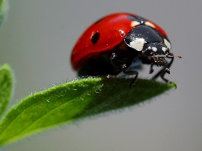 | All about Art  Loose yourself in the medium of art, you can choose paint, felt tips, crayons, collage or clay and create an art piece base in nature. You can paint a beautiful picture of a sun set, or a sketch of your favourite animal in its habitat. | Beautiful Bugs  Can you spot any bugs in your local park or garden. Do you know the names of the bugs or are there some you’ve never noticed before. Be careful not to disturb these clever creatures and just observe them scientifically, then record all your findings.
Week 3 | 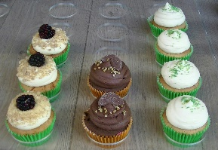 | Mindful Munching  When you have your lunch, snack or dinner practice mindful eating. Do not rush through your lunch so that you can get back to other activities. Instead, take the time to enjoy your Food. Focus on the texture of your meal, the effort that went into making it, and the flavours of the food in your mouth. What do you like about the food, would you improve the taste? How could you adapt the recipe? | Make a Splash  Create a home for bugs, birds and other critters. Fill an old container with water and place a few stones inside, leave this outdoors in a careful spot, keep an eye on your creation and see who comes to visit. Perhaps you will create a home for little bugs, or a water stop for thirsty birds. You can keep a record of the creature hotel by taking photos of its changes.
Week 4 | 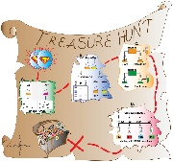 | ​Self Portraits  Paint or draw yourself, you can use a mirror to examine your features, or just do it from memory, make sure you capture the unique, and wonderful things that make you…you! | Create a Mini Rock Garden.  Gather a few pebbles or stones and paint or use chalk to create designs on them, place them in your garden or in a place where you can admire them.
Week 5 | 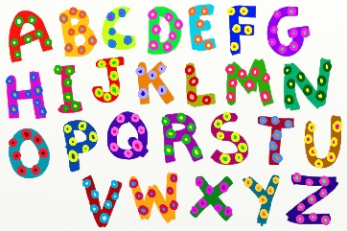 | Alphabet thoughts…  Get your thinking cap on and let’s take a calm break. Can you think of an animal for each letter of the alphabet? What about names? Do you have a favourite letter? Why is it your favourite? You could design a poster showing your letter and all the different things you can think of that begin with that letter. | Sporty Fun  Have a go at beating your personal best by racing faster or jumping further. You can mix up your ideas for racing by doing a bear crawl or jump like a frog. You can run backwards or walk sideways like a crab! Record your timings for a race with a stopwatch and your jumps with a marker on the ground.
Week 6 | 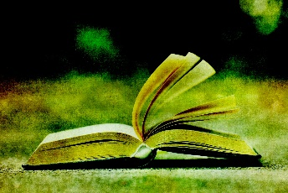 | Reading amongst Nature  Take time to settle outdoors and read your favourite book. Enjoy the sunshine and breeze whilst getting lost in an exciting adventure book, or magical fairy tale, imagine you are the character and enjoy your exciting journey. | Photographer Mission  Take some photos of the outdoors, imagine you are a special science photographer of nature, and you need to capture all the interesting life of earth, what can you see that captures your eye!
Week 7 | 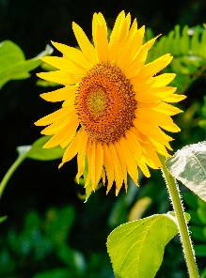 | Funny Poems  Have fun in creating a poem, it can be as short or long as you like. Make it rhyme, base it on your favourite animal, food or about you! Draw lots of pictures, decorate the page and have a go at performing your poem to your friends and family. | Scavenger Hunt  Make a list of things to find outdoors, this could be yellow flowers, long green leaves, unusual, shaped twigs. Collect as many as possible and notice the differences and details of them all. You could create a collage with everything you find.

