
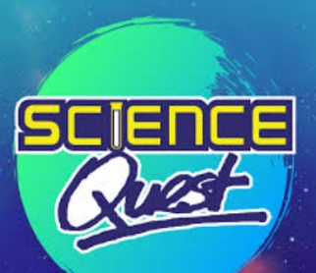
Start with Art
Science Quest
Put your creative skills to the test!
Are you ready to challenge yourself with a Holiday Science Quest?
Earn 10 housepoints for house by completing a challenge and bringing it into school after the half term holiday. This half term we will use our creative skills to explain Science.
Year 1 and 2
Oceans
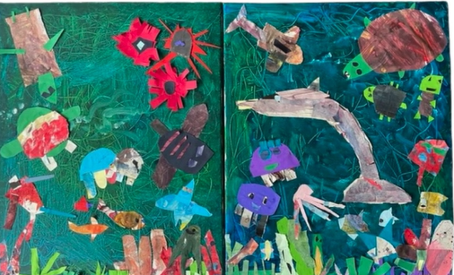

1.Look at the image above.
2.What kind of habitat is this?
3.Name some of the animals and plants you can see in the picture. Are there any you’re not sure about?
4.Can you think of any other animals or plants you might find in this habitat? And can you think of some you would definitely not find living in this habitat?
5.Make your own collage of the ocean habitat and its animals.

