

Winter Science Quest

Are you ready to challenge yourself with a Holiday Science Quest?
Earn 10 housepoints for house by completing a challenge and bringing it into school after the Christmas holidays.
Year 1 and 2
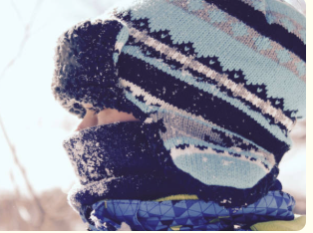
Keep out of the cold
Can you design an outfit which keeps you warm and dry in the coldest, wettest weather?

You will need
- paper
- pencils
- examples of different fabrics/clothes

What to do
- Look at the different clothes/fabrics you have collected
- Describe how they feel.
- Decide which material will keep you warm and dry.
- Draw a picture of yourself wearing your warm clothes
- Label each material ( wool, plastic)

